6.a) Create custom widgets for specific UI elements.

import 'package:flutter/material.dart';

void main() {
runApp(const MyApp());
}

/// ---------- Custom Button ----------
class CustomButton extends StatelessWidget {
final String text;
final VoidCallback onPressed;

const CustomButton({
Key? key,
required this.text,
required this.onPressed,
}) : super(key: key);

@override
Widget build(BuildContext context) {
return ElevatedButton(
style: ElevatedButton.styleFrom(
backgroundColor: Colors.blue,
padding: const EdgeInsets.symmetric(horizontal: 20, vertical: 12),
),
onPressed: onPressed,
child: Text(text, style: const TextStyle(color: Colors.white)),
);
}
}

/// ---------- Custom Card ----------
class CustomCard extends StatelessWidget {
final String title;
final String subtitle;

const CustomCard({
Key? key,
required this.title,
required this.subtitle,
}) : super(key: key);

@override
Widget build(BuildContext context) {
return Card(
margin: const EdgeInsets.all(10),
child: ListTile(
leading: const Icon(Icons.star, color: Colors.orange),
title: Text(title, style: const TextStyle(fontWeight: FontWeight.bold)),
subtitle: Text(subtitle),
),
);
}
}

/// ---------- Main App ----------
class MyApp extends StatelessWidget {
const MyApp({Key? key}) : super(key: key);

void _onButtonTap(BuildContext context) {
ScaffoldMessenger.of(context).showSnackBar(
const SnackBar(content: Text("Button Pressed!")),
);
}

@override
Widget build(BuildContext context) {
return MaterialApp(
home: Scaffold(
appBar: AppBar(title: const Text("Custom Widgets Small Demo")),
body: Column(
mainAxisAlignment: MainAxisAlignment.center,
children: [
const CustomCard(
title: "Flutter",
subtitle: "Build beautiful apps easily",
),
const SizedBox(height: 10),
CustomButton(
text: "Click Me",
onPressed: () => _onButtonTap(context),
),
],
),
),
);
}
}
- CustomButton: A stateless widget wrapping an ElevatedButton, reusable anywhere by passing text and onPressed.
- CustomCard: Displays a title, subtitle, and icon in a clean Card + ListTile format.
- MainApp: Shows both custom widgets in use

Output:
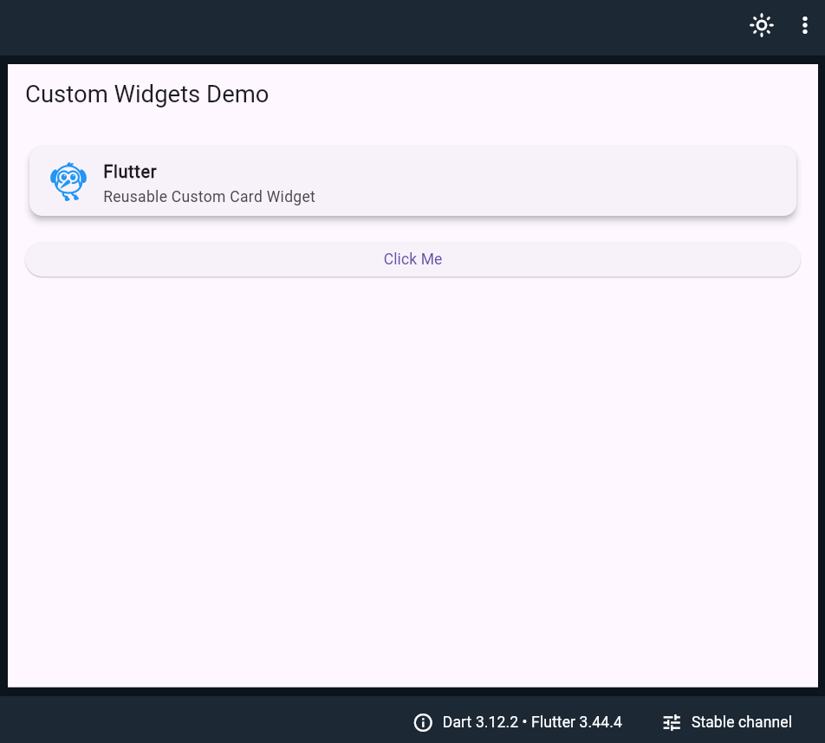
Once we press the click me button it will gives below message will be displayed as BUTTON CLICKED

